International Food Fair

Enjoy exotic dishes form over 25 countries!

Participate in cooking demonstrations!

Taste food from around the world!

Brazil, China, Finland, France, Greece, India, Indonesia, Israel, Italy, Jamaica, Japan, plus many more!

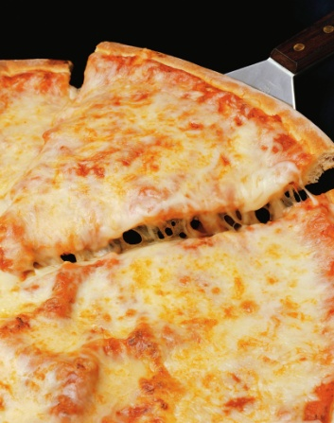
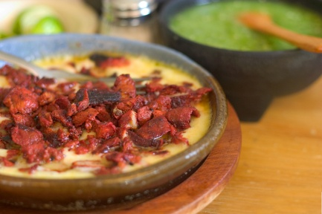

Sunday, December 1
11 a.m. to 2 p.m.
Starmont High School
Café

Call 563-933-2218
for details
Come to a Great Event!

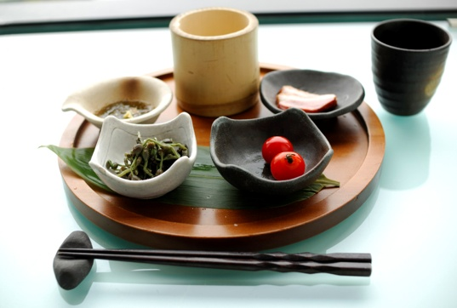

International Food Fair

